2009-04-28

The renovation and reconstruction of bunkers on holes 10 to 18 at the Castle course was at the time of
writing almost completed in respect of excavator work. There is still some adjustments and sowing
of the bunker slope and the surrounding hills.
Work has rolled in good shape despite a fairly difficult winter with snow and soaked until only a few weeks ago. The quality of work, is in my opinion, very high and commitment of management and entrepreneurship has been exemplary.
I hope and believe that our modification work will be appreciated by the players on the circuit.
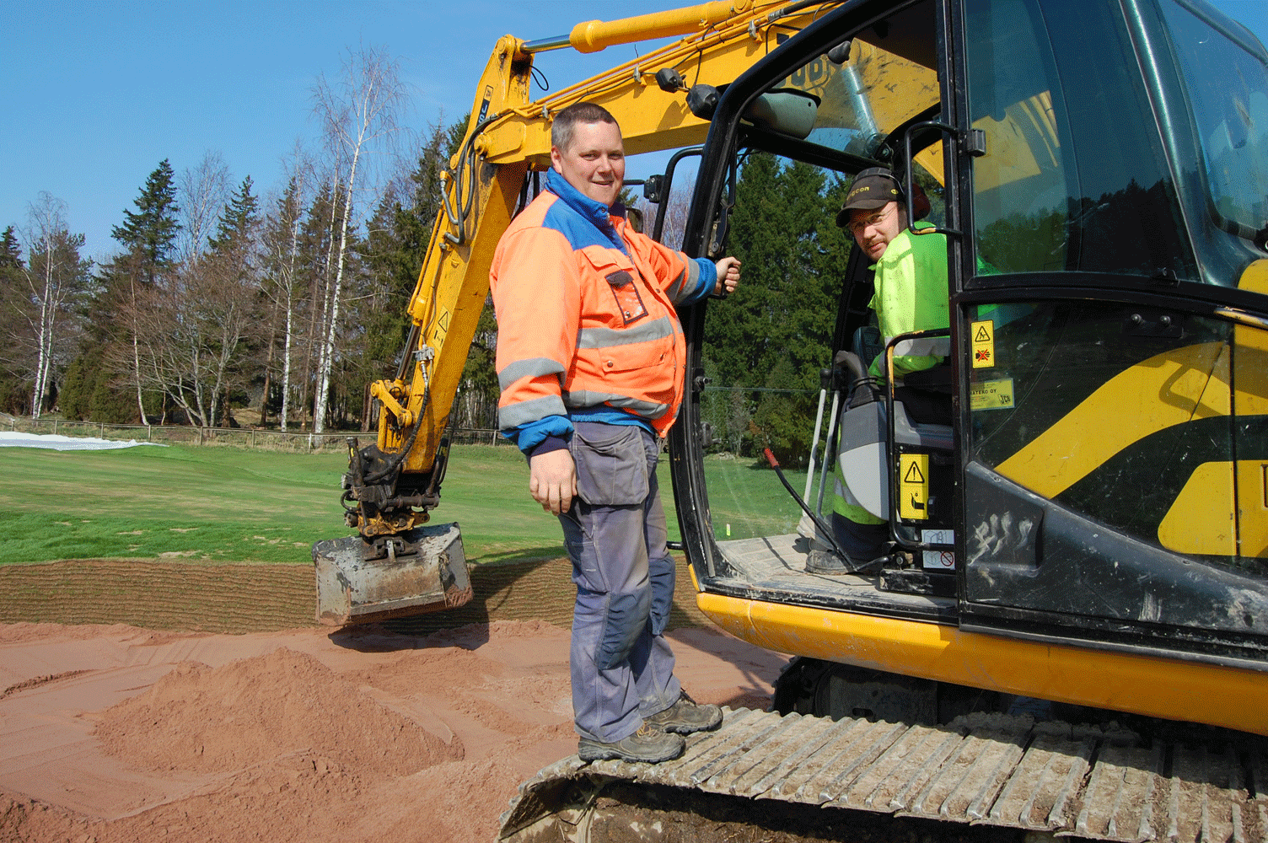
Course responsible Johan Englund (left) and contractor Kenneth Lindqvist at green bunker on hole 16. The figure below shows the new bunker nature with peat edges.
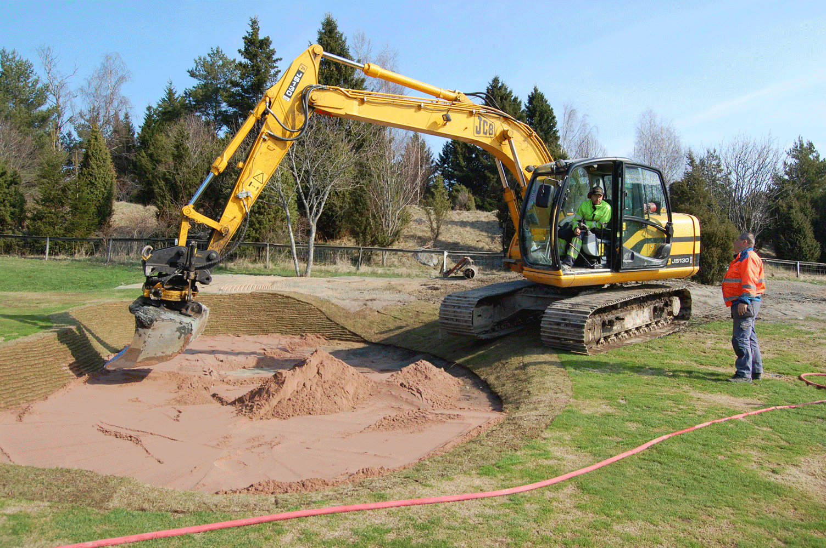

The Kennemer Golf Club

In connection with EIGCA annual meeting in early April, I had the opportunity to play Kennemer GC.
The course is a classical links course and is always ranked high among the continent's golf courses. The course has had different architects over the years of which the best known is Harry S Colt. KLM Open will be played on the course this summer. Unfortunately, I was not able to play the other well-known link course, Noordwijk GC, on this occasion, but I walked around the course during a visit in February. Both courses are worth a visit.
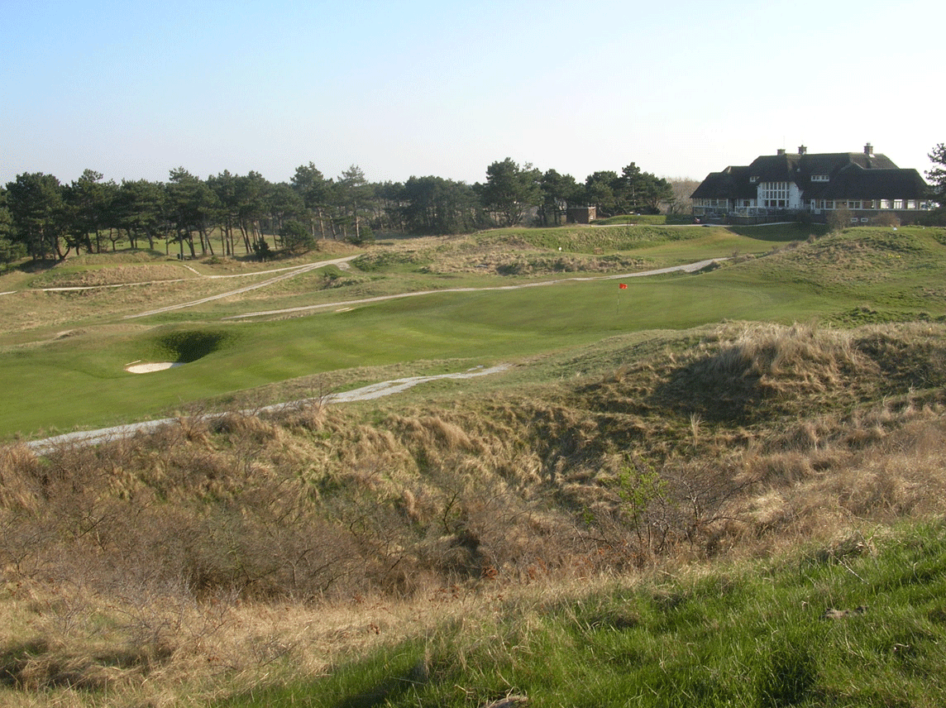
The last hole of the "Colt course" 'below the clubhouse at Kennemer GC.

